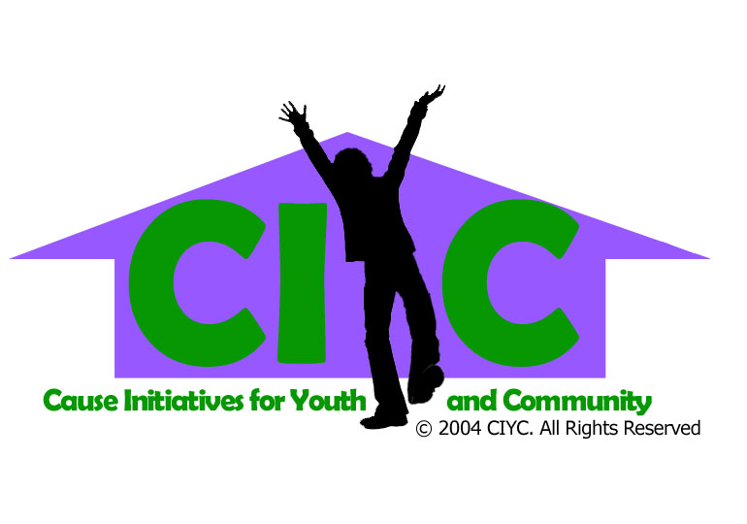
Cause Initiatives for Youth and Community
80 McCallum Drive, Unit 21, Richmond Hill, ON L4C 9X5, Canada
Phone: 905-508-7300 Fax: 905-508-7383 E-Mail: ciyc@rogers.com
www.causesforyouth.com Charitable B/N: 85395 7272 RR0001

PHOTO PURCHASE OR DUPLICATE ORDERED

1. DATE_____________________________________________________________________

.
2. WHICH PHOTO ___________________________________________________________________

3. NAME _____________________________________________________________________

4. ADDRESS __________________________________________________________________

____________________________________________________________________________

5. PHONE _____________________________________________________________________

